COMPANY COLOURS
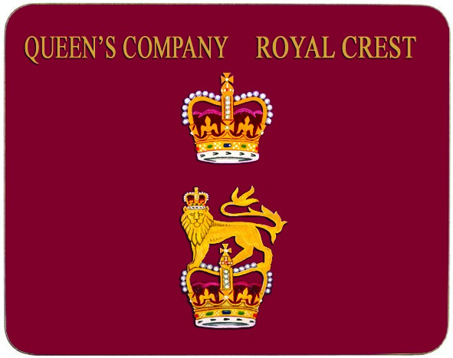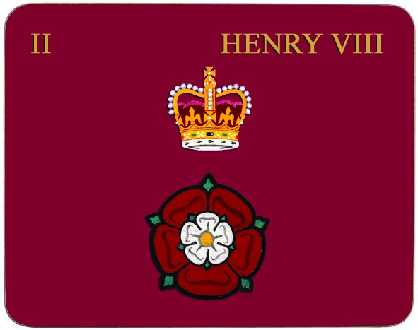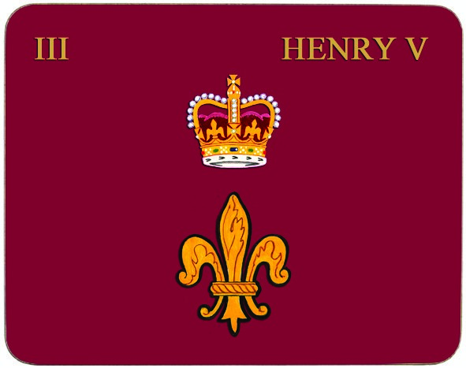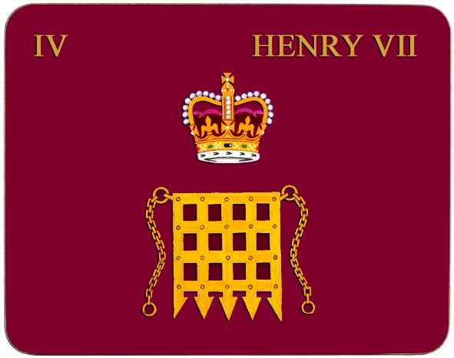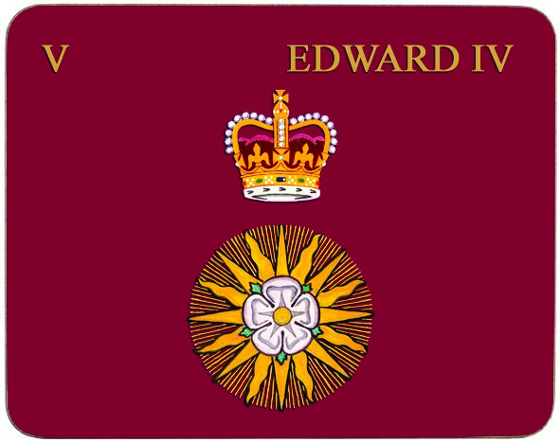
1. The Queen’s Company 2. Number 2 Company, 3. Number 3 Company, 4. Support Company, 5. Headquarter Company,
1st Battalion 1st Battalion 1st Battalion 1st Battalion
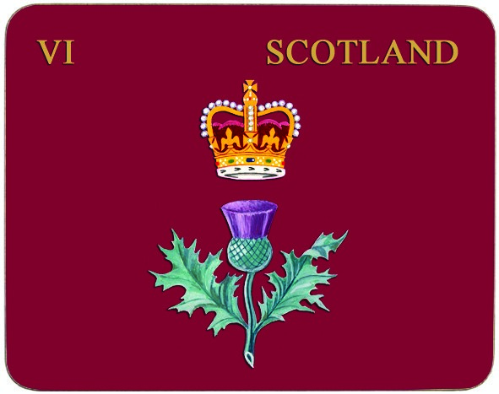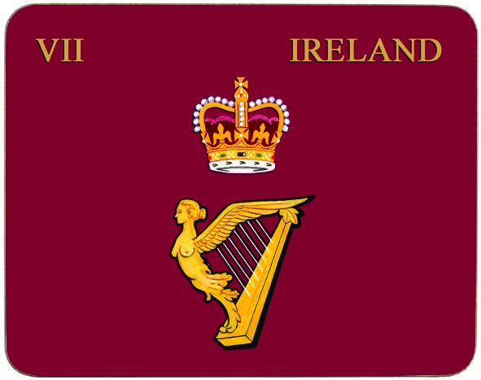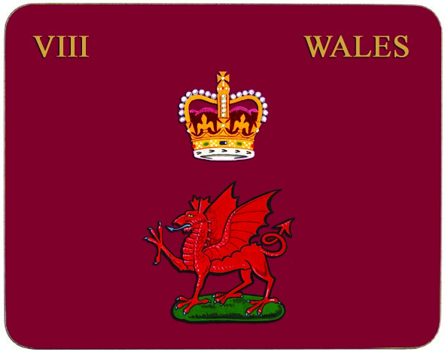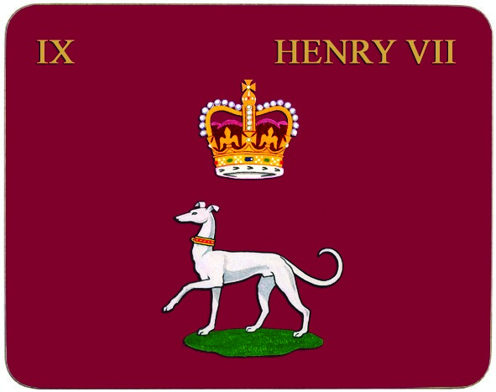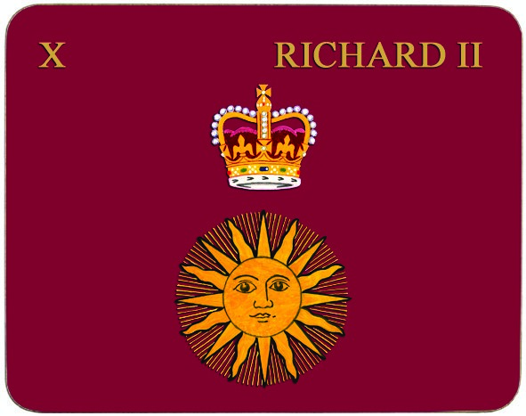
6. Commanding Officer, 7. Senior Major, 8. Adjutant, 9. Previously 2 Battalion 10. Previously 2 Battalion
1st Battalion 1st Battalion 1st Battalion
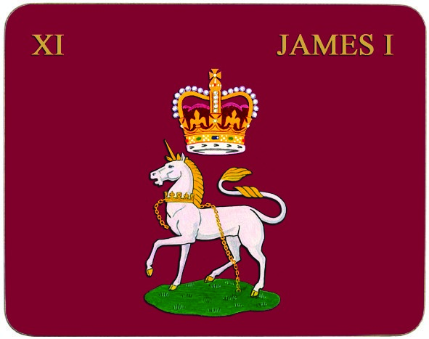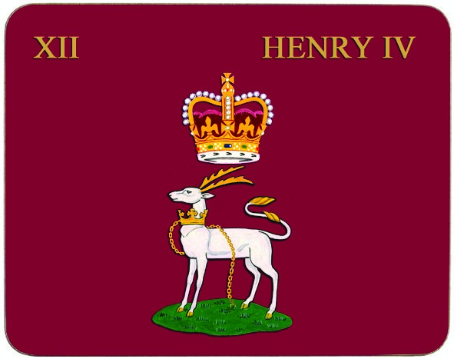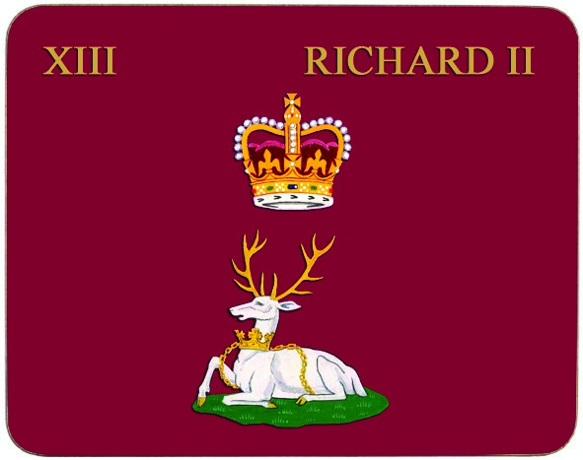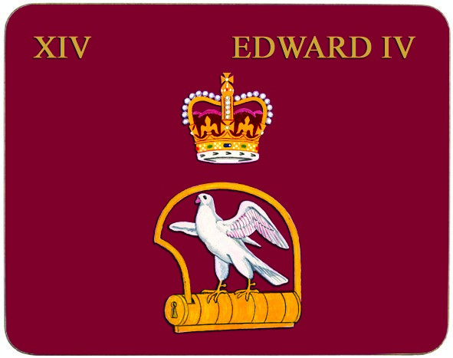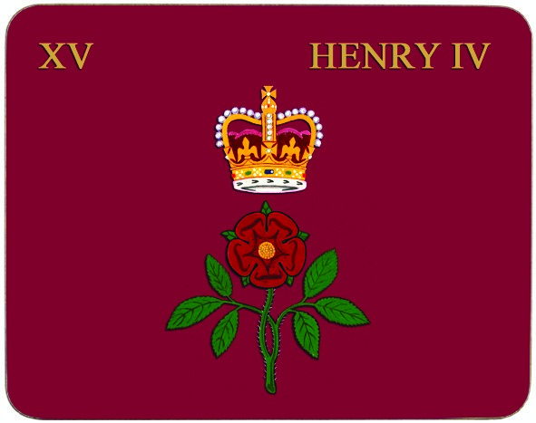
11. Regimental Headquarters, 12. Nijmegen Coy, 13. Previously 2 Battalion 14. Previously 2 Battalion 15. Previously 2 Battalion
2nd Battalion 2nd Battalion
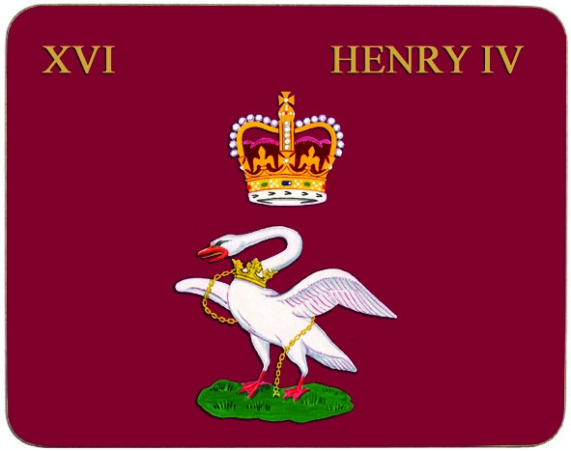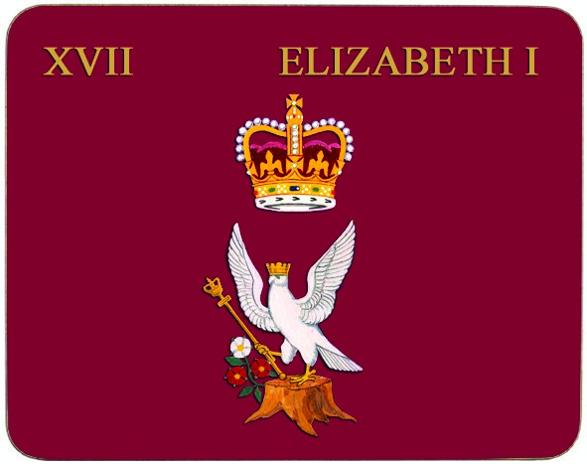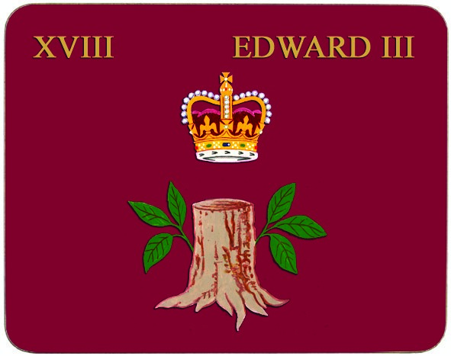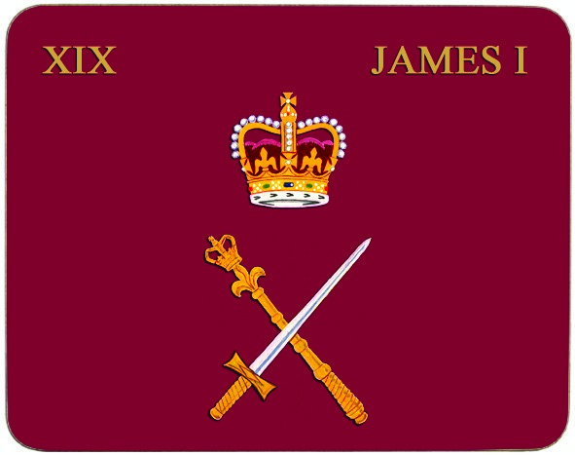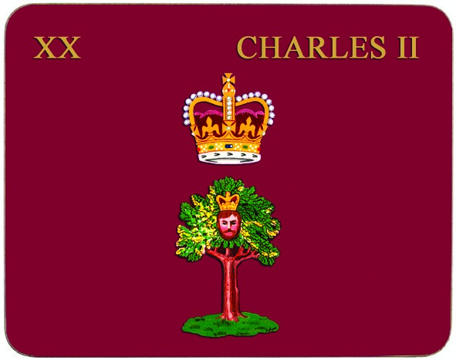
16. Previously 2 Battalion 17. Previously 3 Battalion 18. Previously 3 Battalion 19. Previously 3 Battalion 20. Inkerman Coy,
3rd Battalion
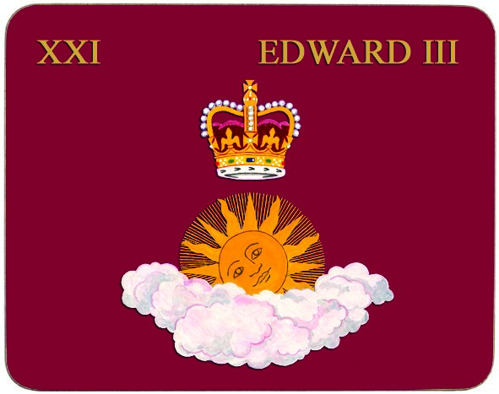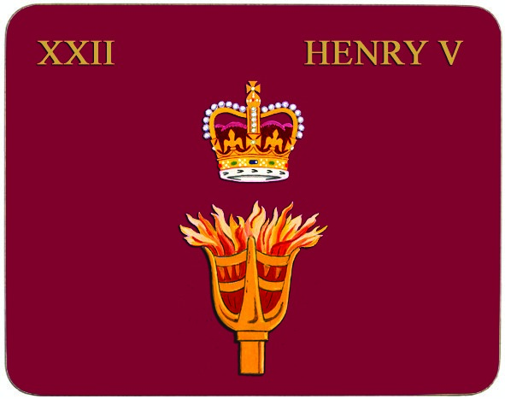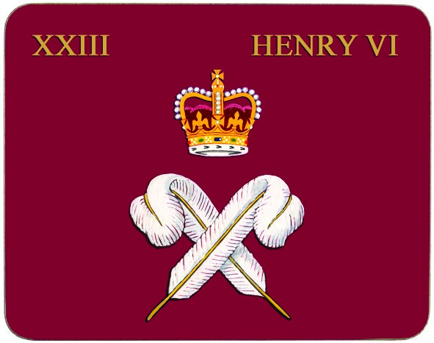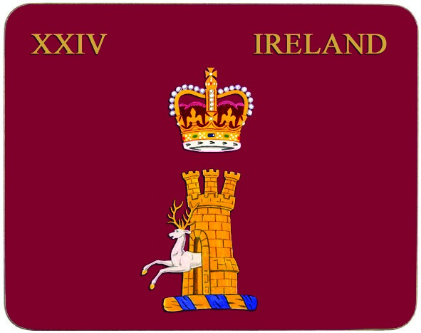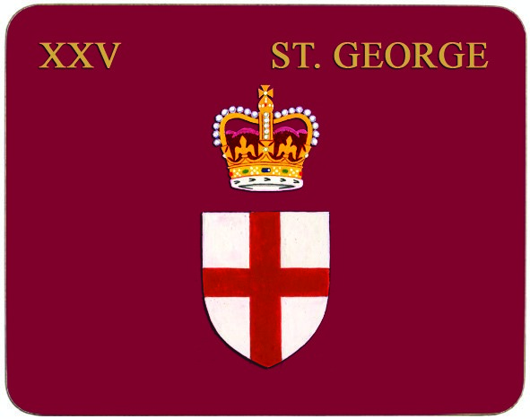
21. Previously 3 Battalion 22. Previously 3 Battalion 23. Previously 3 Battalion 24. Previously 3 Battalion 25. 13th Company

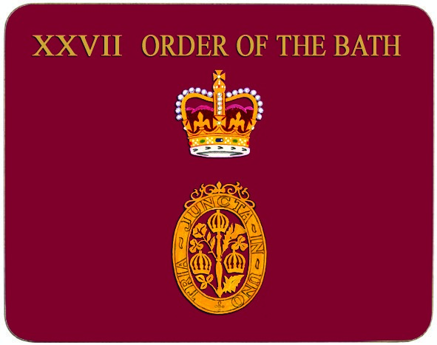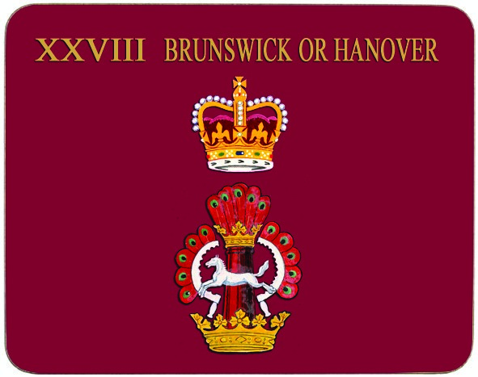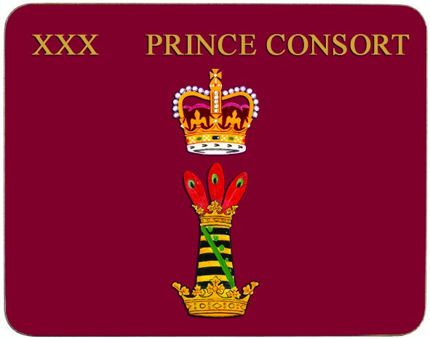
26. 14th Company 27. Regimental Lieutenant 28. Regimental Adjutant 29. 15th Company 30. Regimental Headquarters
THIS IS THE GENERALLY ACCEPTED ALLOCATION OF COMPANY COLOURS, ALTHOUGH YOU SHOULD BE AWARE THAT THESE HAVE BEEN RE-ALLOCATED OVER THE YEARS.

Serving Mat, Placemat and Coaster
Order Form
Bought to you by Club Matters

- Please fill in the details below in BLOCK CAPITALS

Name:
Address:

Telephone:
Email:
- Please allow up to 6 weeks for delivery
- If you have any queries please contact the Association NCO on 020 7414 3285 or email: assnnco@grengds.com
- This form can also be completed and returned via email
- The Postage Costs are: Set of Coasters £4.50
Set of Placemats £8.00
Set of Serving Mats £6.50 Note: Postage for any combination of two sets e.g. 1 Set of Coasters and 1 Set of Placemats, is £12.00. If you wish to order all three sets the postage is £16.50. Please add all postage separately in the box provided below and remember to include it in the Grand Total

Postage:
£
£
Payment information
- Please make cheques payable to:
‘Grenadier Guards Association’
- Payment can be made via PayPal paying the email address:
assnnco@grengds.com
- Payment by BACS:
- Account Number: 00341551
- Sort Code: 30-11-75
- Reference: RCM <Your Initial(s) and Surname>

£
£
£

£
£

£
SERVING MATS (382 x 292mm)
£29.00 per set of 2

Please indicate in the relevant box(es) the number of Serving Mats of each Colour you would like, as displayed overleaf. Please note, Serving Mats are sold in a set of two only.

Number of Sets

Sub Total Excl. Postage

Summary of Costs (please double-check your calculations):

Coasters Excl. Postage:

Placemats Excl. Postage: Grand Total:

Serving Mats Excl. Postage:

21 22 23 24 25 26 27 28 29 30
11 12 13 14 15 16 17 18 19 20
1 2 3 4 5 6 7 8 9 10

21 22 23 24 25 26 27 28 29 30
11 12 13 14 15 16 17 18 19 20
1 2 3 4 5 6 7 8 9 10

21 22 23 24 25 26 27 28 29 30
11 12 13 14 15 16 17 18 19 20
1 2 3 4 5 6 7 8 9 10

PLACEMATS (293 x 216mm)
£42.00 per set of 6

Please indicate in the relevant box(es) the number of Placemats of each Colour you would like, as displayed overleaf. Please note, Placemats are sold in a set of six only.
Number of Sets

Sub Total Excl. Postage

COASTERS (100 x 100mm)
£23.00 per set of 6

Please indicate in the relevant box(es) the number of coasters of each Colour you would like, as displayed overleaf. Please note, Coasters are sold in a set of six only.
Number of Sets

Sub Total Excl. Postage

